**Rollback or Undo a Changeset in TFS Version Control**

A [changeset](https://docs.microsoft.com/en-us/vsts/tfvc/find-view-changesets) is a permanent part of the history of your version-controlled items and cannot be undone or removed. However, you can roll back the effects of one or more changesets.

**To perform roll back of failure or defect changeset , steps listed below :**

* Connect to the source controller (TFS) and do ‘Get latest version’
* **“Get Latest Version” :** to make sure your local project repository gets all latest changes from Central repository.

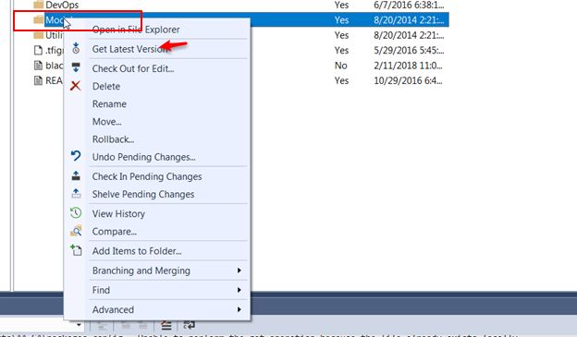

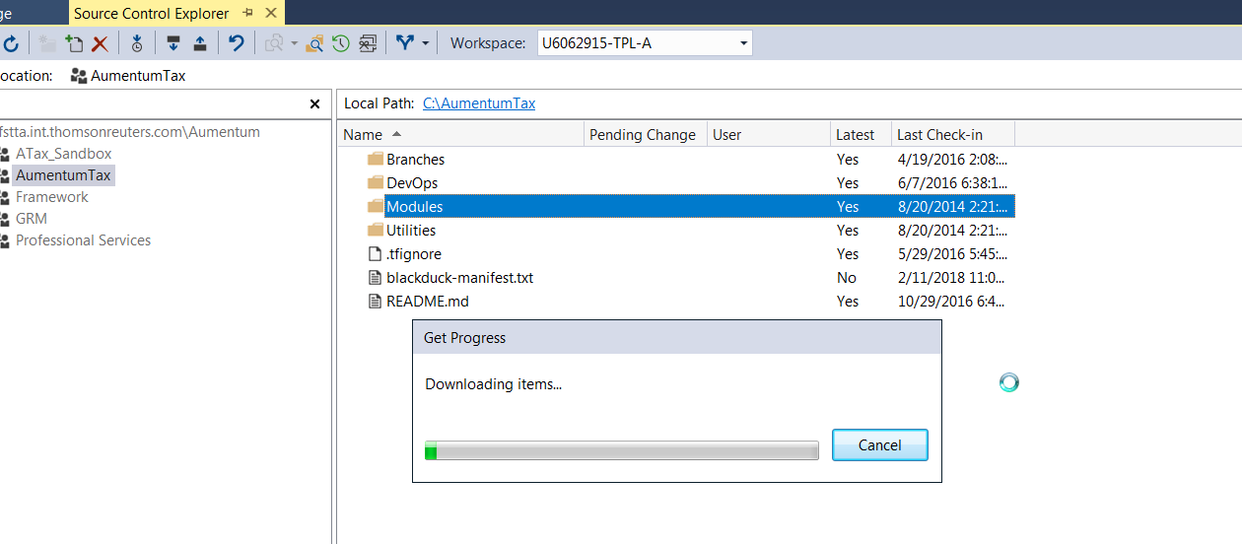

* In the History window, open the shortcut menu of a version and choose **Rollback Entire Changeset**.

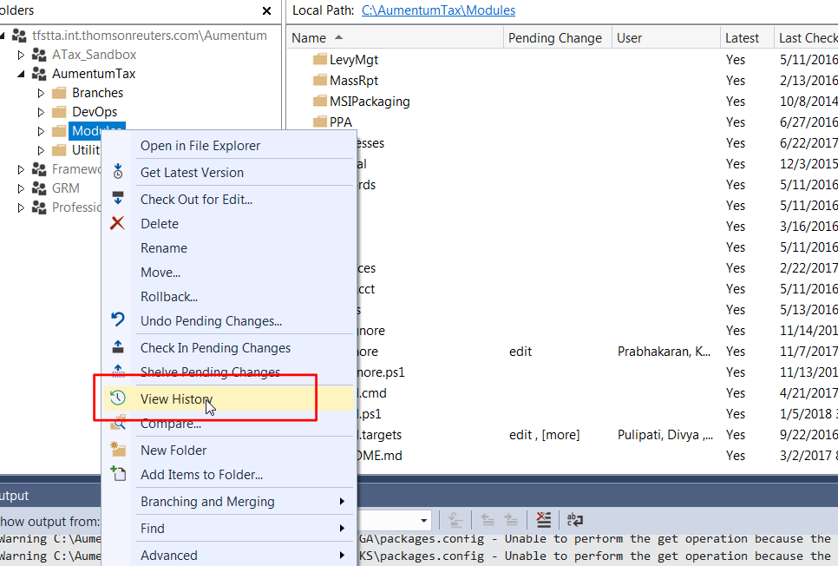

* In Source Control Explorer, select an change set item, open its shortcut menu, and choose **Rollback**.

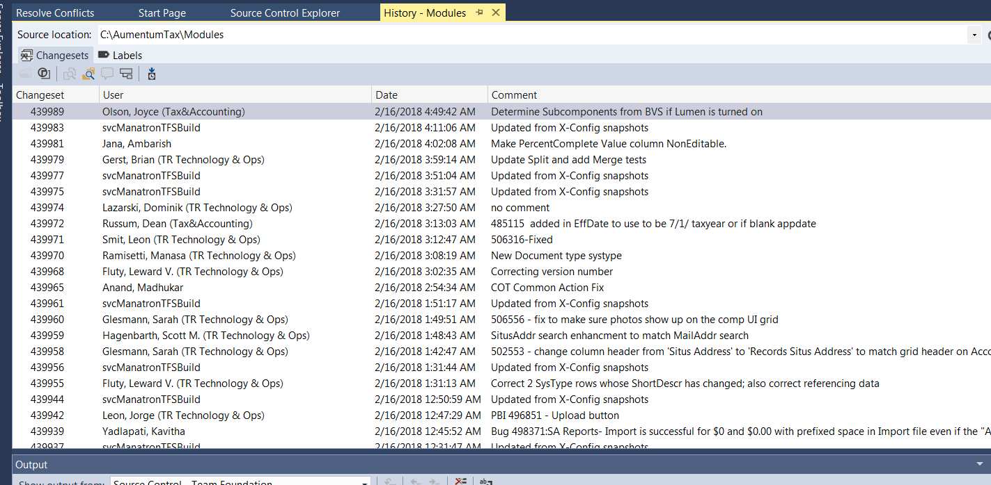

**Note:** The items you select determine the scope that the rollback changes

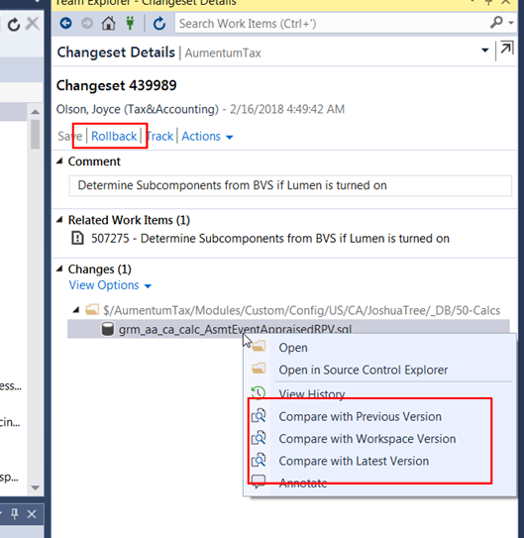

Under changeset details, list of changes and included in the specific changeset and option to compare with its previous Version of files

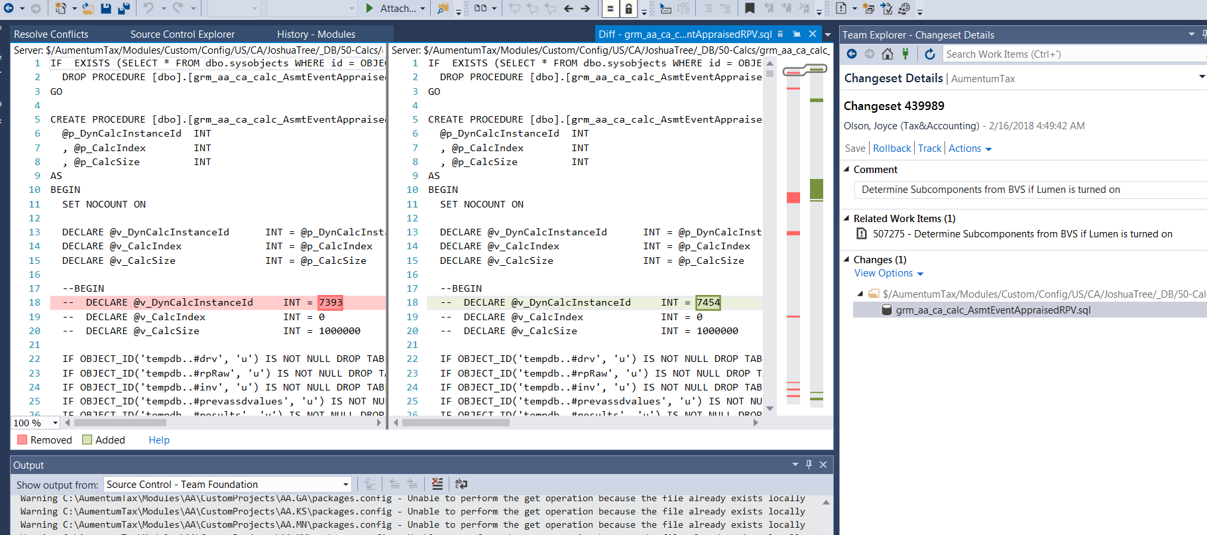

* Add comment to the Changeset

Note : We place “[ROLLBACK] “ in the comment along with the comment of the changeset we are rolling back.  This allows someone to see historically that we checked in a changeset with comment “ adding various code changes”, then later if that changeset fails and you roll it back we’ll see “[ROLLBACK] adding various code changes” in the history

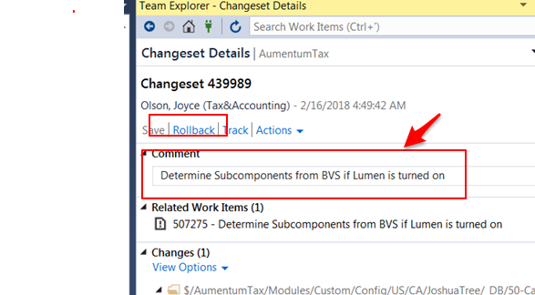

* Check that the pending changes are correct (the rollback command will revert the entire changeset not just the file you selected)
* Check in

Note: A new Build gets triggered within Jenkins Master Job, with latest check in changes.